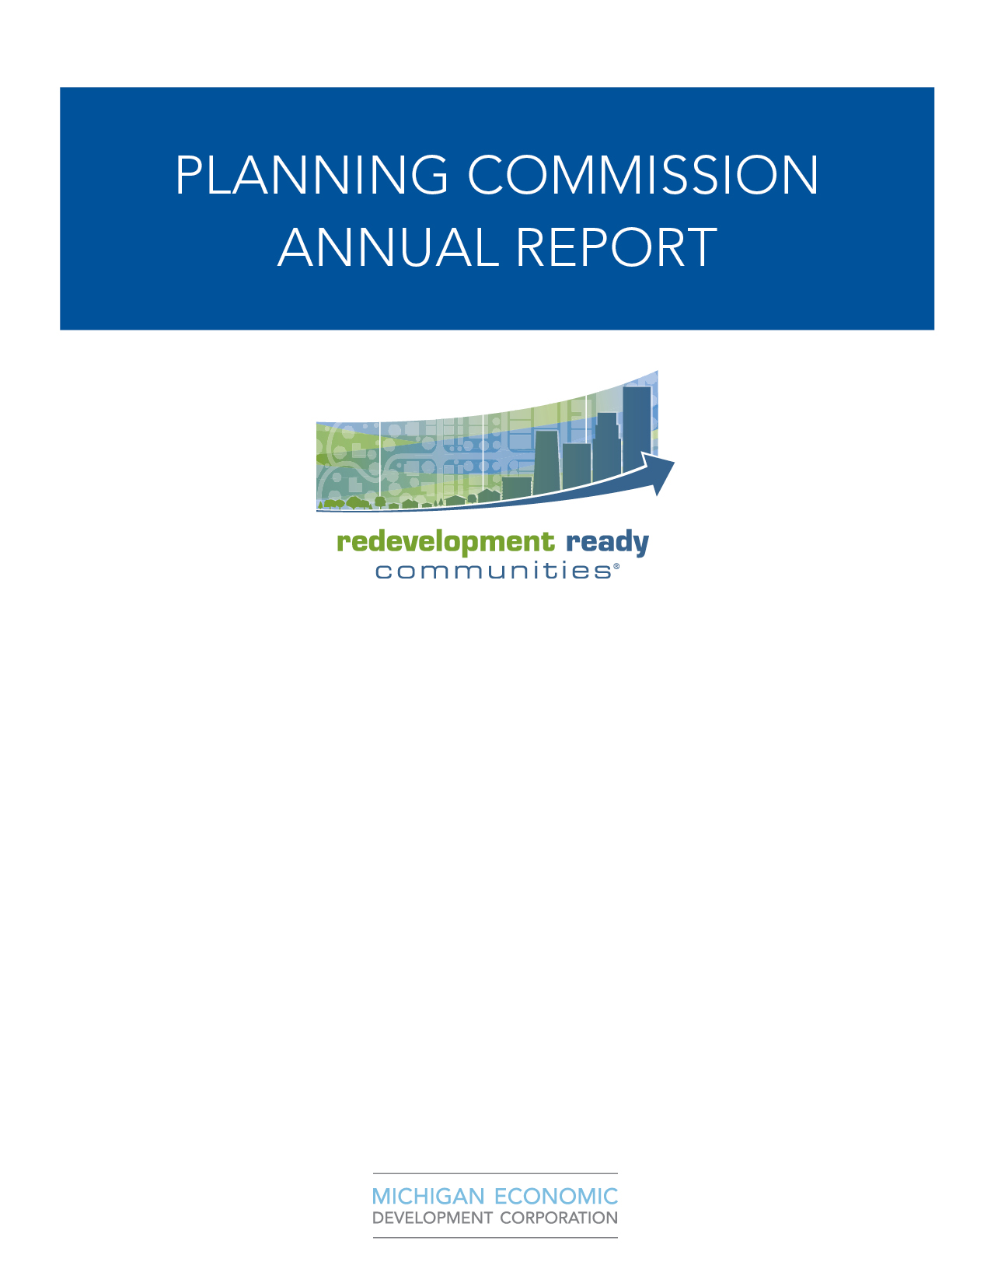
2025

Introduction

Briefly discuss the roles and responsibilities of the planning commission and perhaps the zoning board of appeals. Great place to highlight any notable trainings or other accomplishments. This is a great opportunity to thank board members for their service.

Outline the purpose of this report

It’s called for in the Michigan Planning Enabling Act:
“A planning commission shall make an annual written report to the legislative body concerning its operations and the status of planning activities, including recommendations regarding actions by the legislative body related to planning and development.”

Increases information-sharing between staff, boards, commission and the governing body

Allows for anticipation of upcoming issues and priorities, in order to prepare and budget, if necessary

Opportunity to thank board and commission members for their time and good work

Membership

Planning commission member | Term expiration
Robert Byczek, Jr, Chair | 12/31/2026
Mike Hoinowski | 12/31/2027
Benjamin Garcia | 12/31/2025
Adrienne Baker | 12/31/2028
John Kolbas, Vice Chair | 12/31/2025
Michael Poindexter | 12/31/2026
Vacant | 12/31/2025

- Meetings (MPEA requires four meetings annually)

- The Iron River Planning Commission met six times. This meets the requirements of the MPEA.
- Steering Committee met zero times as of January 2025 to review new zoning ordinances.

Master plan review
 Review goals and recommendations of the plan and indicate progress, include goals of the commission that may not be included in the master plan
 Include the action plan table from the plan and indicate progress, actions completed, and next year’s priorities
 Identify any potential plan amendments to work on for the upcoming year that can be prepared and adopted then incorporated at a later date
 Use master plan update review table (from the “Master Plan Update Guide”) to decide whether the plan needs to be amended

A new Master Plan, provided by Beckett and Raeder was adopted in March 2022.

Zoning ordinance amendments
 Document the section numbers amended and indicate any work in progress
 Review rezoning requests; indicate location, request description, and status
 Identify any zoning ordinance updates to undertake in the upcoming year

- Zoning Ordinance Re-write approved by Planning Commission 3/18/2025 for Council Consideration
- Zoning Ordinance Re-write approved by the City Council 4/16/2025
- New Zoning Ordinance went into effect 5/30/2025
- Drafting Food Truck Ordinance
- Updating Rental Registration and Inspection Ordinance

Development reviews (consult your project tracking mechanism to fill in this information)

Project type | Location | Description | Status | Recommendation to legislative body | Date of action
CIP |  |  | Pending
Home Occupation | Cayuga Street | Interior Auto Detailing | Approved | N/A | 1/09/2025
Home Occupation | Forbes Road | Tattoo Parlor | Approved | N/A | 5/8/2025
Home Occupation | Mineral Avenue | Dog Groomer | Approved | N/A | 6/12/2025

- Variances (Review actions taken by the Board of Zoning Appeals; request summary from BZA)

Variance type | Location | Description | Status | Recommendation to legislative body | Date of action
Variance for two additional accessory structures | Ice Lake Road | Didn’t comply with setbacks | Approved | N/A | 6/10/2025
Variance for construction of self-storage facility | Spruce Street | Not enough acres to place storage facility | Denied | N/A | 7/16/2025
Variance for placement of self-storage facility | Spruce Street | Begin work before obtaining additional land | Denied | N/A | 8/28/2025
Variance for placement of accessory structure | Allen Street | Extending a garage | Approved | N/A | 10/15/2025

- Actions by legislative body (Review actions taken by the legislative body related to planning and development)

Approved CIP Plan as recommended by PC - PENDING
Approved Annual Report as recommended by PC - PENDING

- Zoning map (Review with listed development and rezoning requests to analyze potential trends)

N/A



Trainings attended (consult your training tracking log to fill in this information)

Topic /description | Date
Chairmen Bob Byczek sent out: | 10/13/2025
1)Planning Commissioners Handbook | 10/13/2025
2)City of Iron River – Planning Commission Bylaws | 10/13/2025
3)Michigan Planning Enabling Act (Act 33 of 2008) (MCL-Section 125.801 through MCL-Section 125.3885) | 10/13/2025
4)Michigan Zoning Enabling Act (Act 110 of 2006) (Section 125.3101 through Section 125.3601) | 10/13/2025
5)Robert’s Rules of Order – Quick Reference and Tools for Meetings | 10/13/2025
6)Open Meetings Act (Act 267 of 1976) | 10/13/2025

Potential training topics in the upcoming year, based on goals and priorities
Topic /description
RRC – Best Practices 1 – 6
Planning

- Joint meetings
N/A

- Other notable items to consider including:
- Working on Updating Bylaws

